1. **yoRemove upload image Done:**
2. **Mention which field is mandatory and which is not mandatory.**
3. **notification when user is registered “Please confirm your email”: Done:**
4. **Remove profile from here, will only show in the drop down on the left.**

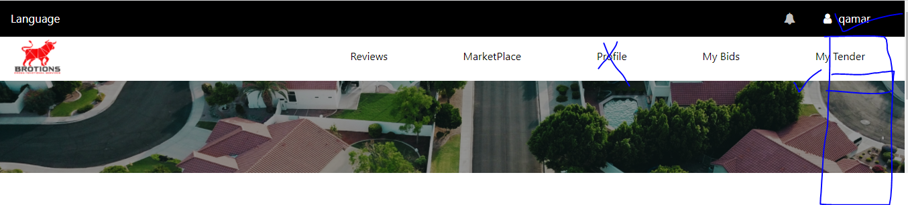

1. **Reference number is not mandatory.**
2. **The current address will come from registration. And other address user have to write**

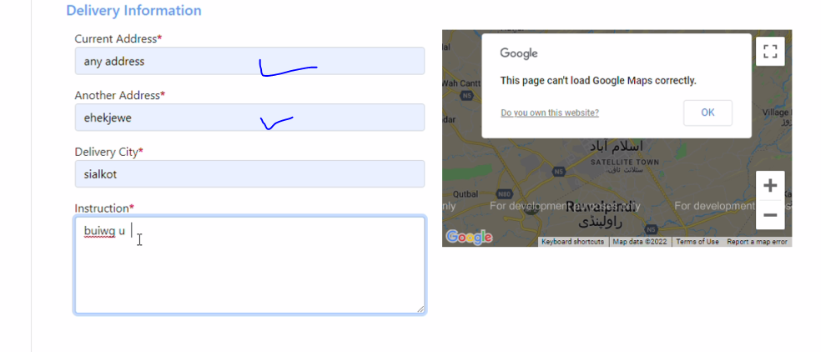

1. Change my previous qualification to tenders.

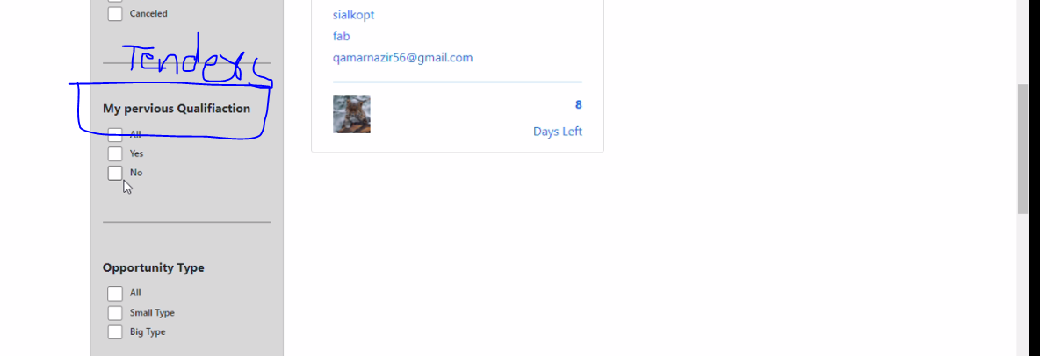

1. **Change not required to hide**

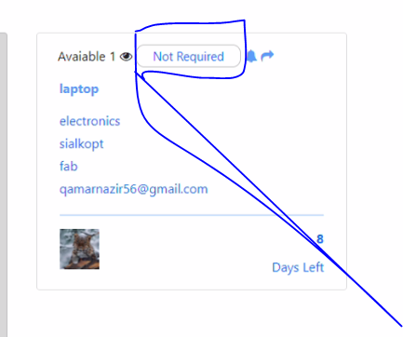

1. Want to change these from admin

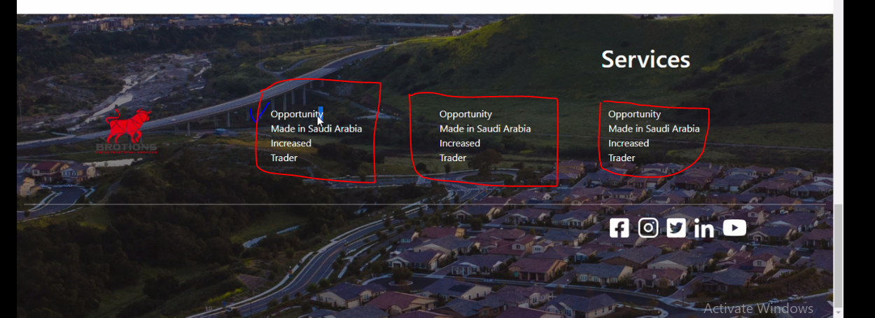

1. Show price with document when bidding.